Robust Speed Control of a Sensorless Driving System with Field-Oriented Induction Machine

Iulian M.T. Birou
Technical University of Cluj-Napoca
Department of Electrical Drives and Robots
C. Daicoviciu Str. 15, 3400 Cluj-Napoca, Romania
Tel: +40-264-401242; E-mail: birou@edr.utcluj.ro

Abstract - A control structure based on the H∞-theory is proposed to implement a sensorless speed-control drive-system with induction machine. The rotor speed is estimated in two different ways, namely by a model reference adaptive system based algorithm and by a full-order observer based structure, with information from stator variables fundamentals (voltage, current). The major sensorless solution disadvantages, namely the variation of parameters in the estimating algorithm and the low-speed and zero stator-frequency problems, are now transferred to be solved by the robust controller. Computer simulated results are given to show the robustness of the sensorless control drive system.

Index Terms – Induction machine, sensorless driving system, robust H_{oo} control.

I. Introduction

Vector control of induction motors has been widely used for their high dynamic performances [1], [2]. Recently the sensorless vector control (without the speed sensor) is much more focused and has progressed. The need for tacholess speed and torque control of induction machines has become widely recognized because of the cost and fragility of a mechanical speed sensor and because of the difficulty of installing the sensor in many applications [3], [4]. It combines favorably the cost advantage with increased reliability due to the absence of the mechanical sensor and its communication cable. Speed sensorless induction motor drives are today well established in those industrial applications in which no persistent operations at lower speed occurs.
In all the applications with sensorless induction machine drives a robust solution for general industrial use has yet to be found. As to the robust control theory it is based on the two Algebraic Riccati Equation (ARE) algorithms as a solution to the standard H∞ control problem [5], [6]. This way developed controller guarantee robust stability of the closed-loop system against uncertainties described by additive or multiplicative perturbations [7].

II. Simplified model of the field-oriented controlled induction machine

In the designing procedure of the controllers, it is important to know the transfer function of the process. A transfer function, which describes exactly the behavior of the induction machine, is almost impossible to obtain, because of the nonlinearities of the mathematical model of the machine [1], [2], [8]. That's why a simplified transfer function of the process is used to design the speed controller, then the control law is introduced in the not simplified and nonlinear "original" control structure, in order to simulate and analyze the dynamic behavior of the mechanical and electrical variables (speed, torque, currents, voltages, etc.). The simplified transfer function in this case describes the linearised model of the induction machine corresponding to a steady state working point is presented in Fig. 1.
In the field-oriented control (FOC) of the induction machine the rotor flux is used as imposing the reference system. In this case the speed controller has as input the speed error and it computes the control variable as the active component of the stator current (denoted here i_{sqλr}).
Fig.1. Simplified speed close-loop control
structure of an induction machine.
Using the torque producing expression:
$m_{e}=\frac{3}{2}z_{p}\frac{L_{m}}{L_{r}}ℑm\left({\underline{i}}_{s}{\underline{Ψ}}_{r}^{}\right)=\frac{3}{2}z_{p}\frac{L_{m}}{L_{r}}Ψ_{r}i_{\text{sq}λ_{r}}$, (1)
and the motion equation
$m_{e}\text{=Js}ω_{r}\text{+B}ω_{r}{\text{+m}}_{r}$, (2)
with
$ω_{r}=\frac{ω}{z_{p}}=n_{r}\frac{2π}{\text{60}}$, (3)
the simplified transfer function of the rotor-flux oriented induction machine can be written [9]:
$P\left(s\right)=\frac{n_{r}}{i_{\text{sq}λr}^{}}=K_{1}\frac{K_{2}}{T_{m}s+1}=\frac{K_{m}}{T_{m}s+1}$. (4)

III. Sensorless control algorithm

Various concepts for controlled high-performance induction motor drives without speed sensor have been developed in the past few years [10], [11]. Ongoing research has focused on providing sustained operation at high dynamic performance in the very low speed range, including zero speed and zero stator frequency [12], [13]. In position sensorless control two factors are important, namely, wide speed range capability and motor parameter insensivity. In many existing speed identification algorithms, the rotor speed is estimated based on the rotor flux observer, by forcing the error between the reference model and the adjustable model to be zero. Therefore, these algorithms are, to a certain degree, machine parameter dependent. It is known that the simultaneous estimation of the rotor speed and the rotor resistance is very difficult, especially under steady state conditions.

Fig.2. Block diagram of the speed sensorless
vector control of the induction machine.
Two different algorithms will be presented to estimate the rotor speed, one based on the Model Reference Adaptive System (MRAS) and the other on a Full Order Observer (FOO). Both algorithms are parts of the speed sensorless vector control structure of the induction machine (IM), presented in Fig. 2.

A. Model Reference Adaptive System Algorithm for Speed Identification

In order to achieve the position sensorless control, the rotor speed estimation has to be indirectly derived based on the measured stator voltages and currents. Therefore, a mathematical model of the induction machine is needed. The model is described in the stationary (stator) reference frame and presented in the Appendix.
The block diagram of the MRAS speed identification is shown in Fig. 3. It contains a reference model, an adjustable model and an adaptive algorithm. Both models have as inputs the stator voltages and currents. The reference model outputs a performance index p and the adjustable model a performance index $\overset{}{p}$. The difference between the two values is used by the adaptive algorithm to converge the estimated speed $\overset{}{ω}$ to its real value.
In order to estimate the rotor speed accurately, the performance index of the reference model has to be robust over the entire speed range and insensitive to the machine parameters.
According to the equations of the induction machine described in the Appendix, we can obtain the value of the rotor flux phasor based on stator equations:

Fig. 3. Model reference adaptive system algorithm (MRAS)
for speed identification.

$\frac{d{\underline{Ψ}}_{r}}{\text{dt}}=\frac{L_{r}}{L_{m}}\left({\underline{u}}_{s}−R_{s}{\underline{i}}_{s}−L_{σ}\frac{d{\underline{i}}_{s}}{\text{dt}}\right)$ (5)
and the same rotor flux phasor based on the rotor equations:
$\frac{d{\underline{Ψ}}_{r}}{\text{dt}}=−\frac{1}{τ_{r}}{\underline{Ψ}}_{r}+jω{\underline{Ψ}}_{r}+\frac{L_{m}}{τ_{r}}{\underline{i}}_{s}$. (6)
Considering the back EMF being:
$\underline{e}=\frac{L_{m}}{L_{r}}\frac{d{\underline{Ψ}}_{r}}{\text{dt}}$ (7)
and decupling (5) on the fix reference frame d-q, we obtain:
$e_{d}=u_{\text{sd}}−R_{s}i_{\text{sd}}−L_{σ}\frac{{\text{di}}_{\text{sd}}}{\text{dt}}$; (8)
$e_{q}=u_{\text{sq}}−R_{s}i_{\text{sq}}−L_{σ}\frac{{\text{di}}_{\text{sq}}}{\text{dt}}$. (9)
Considering a formal magnetizing current
${\underline{i}}_{m}=\frac{1}{L_{m}}{\underline{Ψ}}_{r}$ (10)
and decupling (6) on the fix reference frame d-q, we have:
$e_{\text{md}}=−\frac{L_{m^{2}}}{L_{r}}\left(\frac{1}{τ_{r}}i_{\text{md}}+{ωi}_{\text{mq}}−\frac{1}{τ_{r}}i_{\text{sd}}\right)$; (11)
$e_{\text{mq}}=−\frac{L_{m^{2}}}{L_{r}}\left(\frac{1}{τ_{r}}i_{\text{mq}}−{ωi}_{\text{md}}−\frac{1}{τ_{r}}i_{\text{sq}}\right)$. (12)
The reference model is described based on (8) and (9), resulting that it is parameter dependent, namely with the stator resistance R_{s} and the equivalent inductance L_{σ}. In the reference model there are no integral operations, so the model can be used also for low speed estimation. To improve the robustness of the reference model one of the two machine parameters can be avoided by choosing an optimal way to define the reference model performance index p. To eliminate the effect of the inductance L_{σ} (8) and (9) are cross multiplied by the derivates of the two stator current components and then substract, obtaining:
$p=u_{\text{sd}}\frac{{\text{di}}_{\text{sq}}}{\text{dt}}−u_{\text{sq}}\frac{{\text{di}}_{\text{sd}}}{\text{dt}}−R_{s}\left(i_{\text{sd}}\frac{{\text{di}}_{\text{sq}}}{\text{dt}}−i_{\text{sq}}\frac{{\text{di}}_{\text{sd}}}{\text{dt}}\right)$ (13)
Equation (13) describes the performance index of the reference model. To obtain the performance index of the adjustable model, same mathematical operations applied to (11) and (12) give:
$\begin{aligned}\overset{}{p}=\frac{L_{m^{2}}}{L_{r}}\frac{1}{τ_{r}}\left(i_{\text{sd}}\frac{{\text{di}}_{\text{sq}}}{\text{dt}}−i_{\text{sq}}\frac{{\text{di}}_{\text{sd}}}{\text{dt}}\right)− \\ −\frac{L_{m^{2}}}{L_{r}}\frac{1}{τ_{r}}\left(i_{\text{md}}\frac{{\text{di}}_{\text{sq}}}{\text{dt}}−i_{\text{mq}}\frac{{\text{di}}_{\text{sd}}}{\text{dt}}\right)− \\ −\frac{L_{m^{2}}}{L_{r}}\overset{}{ω}\left(i_{\text{mq}}\frac{{\text{di}}_{\text{sq}}}{\text{dt}}−i_{\text{md}}\frac{{\text{di}}_{\text{sd}}}{\text{dt}}\right)\end{aligned}$ (14)
having the two formal magnetizing current components described by:
$\frac{{\text{di}}_{\text{md}}}{\text{dt}}=−\frac{1}{τ_{r}}i_{\text{md}}−\overset{}{ω}i_{\text{mq}}+\frac{1}{τ_{r}}i_{\text{sd}}$; (15)
$\frac{{\text{di}}_{\text{mq}}}{\text{dt}}=−\frac{1}{τ_{r}}i_{\text{mq}}+\overset{}{ω}i_{\text{md}}+\frac{1}{τ_{r}}i_{\text{sq}}$. (16).
Equation (13) is used for the reference model and (14)-(16) for the adjustable model. The error between the two performance indexes
$ε=p−\overset{}{p}$ (17)
is the input for the adaptive algorithm, see Fig. 3. This algorithm estimates the $\overset{}{ω}$ rotor speed in order to converge the performance index of the adjustable model to the performance index of the reference model (converge the error ε to zero).
In designing the adaptive mechanism of the presented MRAS structure, it is necessary to ensure the stability of the control system and the convergence of the estimated speed to the real one. Based on the hyperstability theory [14], following adaptive algorithm is used:
$\overset{}{ω}=K_{p}ε+K_{i}\int{ε\text{dt}}$, (18)
where, K_{p} and K_{i} are the gain parameters of the adaptive algorithm.
The MRAS algorithm presented above can also be used for on-line identification of some parameter of the induction machine, namely the stator resistance or the equivalent inductance or the rotor time constant.

B. Speed and Rotor Flux Estimator Based on a Full Order Observer

The speed estimation strategy with full order observer (FOO) is based on the fundamental excitation variables as information source, like presented in Fig. 4.
The rotor speed estimator is based on comparing the stator current estimate value ${\overset{}{i}}_{s}$ to the actual stator current i_{s} and updating the estimated speed $\overset{}{ω}$ such that the error $i_{s}−{\overset{}{i}}_{s}$ is minimized in some sense. This will be done by using a full-order observer for the estimated stator current, rotor flux and rotor speed, described by equations:
$\begin{aligned}L_{σ}\frac{d{\overset{}{\underline{i}}}_{s}}{\text{dt}}={\underline{u}}_{s}−\left(R_{s}+R_{r}+{jω}_{λ}L_{σ}\right){\overset{}{\underline{i}}}_{s}+ \\ +\left(\frac{R_{r}}{L_{m}}−j\overset{}{ω}\right){\overset{}{\underline{Ψ}}}_{r}+k_{1}\left({\underline{i}}_{s}−{\overset{}{\underline{i}}}_{s}\right)\end{aligned}$; (19)
$\begin{aligned}\frac{d{\overset{}{\underline{Ψ}}}_{r}}{\text{dt}}=R_{r}{\underline{\overset{}{i}}}_{s}−\left[\frac{R_{r}}{L_{m}}+j\left(ω_{λ}−\overset{}{ω}\right)\right]{\overset{}{\underline{Ψ}}}_{r}+ \\ +k_{2}\left({\underline{i}}_{s}−{\overset{}{\underline{i}}}_{s}\right)\end{aligned}$; (20)
$\frac{d\overset{}{ω}}{\text{dt}}=ℜe\left\{k_{3}\left(i_{s}−{\overset{}{i}}_{s}\right)\right\}$, (21)
where ω_{λ} is the speed of the reference frame and k₁, k₂ and k₃ are the gain parameters of the algorithm, calculated from the Ricatti equation. The speed estimator shell converges significantly faster than the mechanical speed control loop in order to ensure good tracking. So, the dynamics of the speed estimator can be neglected as seen from the much slower flux and speed dynamics and thus it can be considered only that values of estimated speed and stator current which have converged to quasi steady-state values.
Fig. 4. Full order observer (FOO) for speed and rotor flux estimator.
IV. Robust control of the sensorless driving system

The extended H∞ control theory is used to design a robust speed-control solution for sensorless induction motor driving system. It satisfies the robust stability characteristics of the control structure as well as the dynamic performances of the driving system. The H∞ optimal control designing problem in the particular case of applying the small gain problem is to form an augmented plant of the process P(s), like in Fig. 5. with the weighting functions W₁(s), W₂(s), W₃(s) and to find an optimal stabilizing H∞ controller, presented in Fig. 6, so that the infinity norm of the cost function T_{y-u} is minimized [5], [15] and is less then one:${\left\|T_{y−u}\right\|}_{¥}<$1.
Considering the robust stability and robust performance criteria, the weighting functions for the optimal H∞ controller are chosen and then the iterative computing process continues, until the norm condition is full fit. The performance design specifications of the speed control loop with the H∞ controller are imposed in frequency domain:
- robust performance specifications: minimizing the sensitivity function S (reducing it at least 100 times to approximate 0.3333 rad/sec).
- robust stability specifications: -40 dB/decade roll-off and at least -20dB at a crossover band of 100 rad/sec.
Considering the robust stability and robust performance criteria, the weighting functions for the optimal H∞ controller are:
$\begin{aligned}\left\{\frac{1}{W_{1}(s)}=W_{1^{−1}}(s)=\frac{1}{γ}⋅\frac{(3s+1)^{2}}{\text{100}} | \right.\end{aligned}$, (22)
where γ represents the actual step value.
Fig. 5. Structure of speed control system with weighted process.
Fig. 6. Robust H∞ controller.

The iterative process continues, until the graphic representation in Bode diagram of cost function T_{y-u} reach his maximum value in the proximity of 0 dB axis. In our case, for γ=39,75 we obtain the infinite norm
${\left\|T_{y−u}\right\|}_{¥}=0,\text{9999}$ (23)
and the corresponding H∞ speed controller is:
$H_{∞}(s)=\frac{\text{2327}s^{2}+\text{22211}s+\text{16495}}{s^{3}+\text{822951}s^{2}+\text{548632}s+\text{91442}}$. (24)
The dynamic performances and the robust and stability performance criteria are performed. The sensitivity function S(s) of the close loop for the nominal plant is:
$S(s)=\frac{1,\text{015}s^{3}+1,5s^{2}+0,\text{66}s+0,\text{09}}{s^{3}+\text{157},2s^{2}+\text{1486},5s+\text{1103},6}$. (25)
The logarithmic Bode diagram of the direct-loop transfer function of the weighted process is presented in Fig. 7. According to them, we establish the following stability parameters:
- crossover band Δω_{Β} = 153,7 rad/sec;
- stability margins:
  - gain margin = 130,3 dB;
  - phase margin = 86,8°.
For the same performance and robust stability specifications, a great number of weighting functions described by (22) can be chosen, so the solution of designing an optimal H∞ controller is not unique.

V. simulated results and conclusions

The control structure will be implemented on a driving system based on a induction machine with following main rated parameters: power P= 2,2kW; speed n=1435 rpm.; stator current I_{s}=4.9A at stator voltage U_{s}=400V; load torque M_{em}=14.7Nm.
Fig. 7. Bode diagram of the direct-loop transfer function.

The simulated results of the MRAS algorithm are presented in figure 8, where the reference model and adjustable model performance indexes (13), (14) and the error (17) are presented for a starting process to the rated speed with rated load torque. The simulated speed of this process and the estimated speed based on the MRAS algorithm are both presented in figure 9.
The simulated results confirm that the estimated speed based on the presented MRAS algorithm properly follows the rotor speed for different load torque or/and speed steps. The error of the estimated speed in the beginning of the starting process is relativ big. By modifying the gain parameters from (18) we can avoid this, but we disturb the control performance parameters (overshooting, stationary error). The reference and the adjustable model contain only derivates (no integrations) so the estimator can be used also at low speed. The derivates of the measured stator currents can be computed by perform ant digital algorithms.
Fig. 8. The performance index of the refernce model p, of the adjustable model p^ and the error index ε.

Fig.9. The rotor speed, estimated speed based on the MRAS algorithm and speed error for a uncontrolled starting process with rated torque.

By using the optimal H∞ controller designed in this paper, the vector-controlled structure is robust to parameter variations as stator resistance and mutual inductance (reference model) or rotor time constant (adjustable model).

Appendix

The mathematical model of the induction machine in the fix reference frame d-q, namely the voltage equations:
$u_{\text{sd}}=R_{s}i_{\text{sd}}+\frac{{dΨ}_{\text{sd}}}{\text{dt}}$;
$u_{\text{sq}}=R_{s}i_{\text{sq}}+\frac{{dΨ}_{\text{sq}}}{\text{dt}}$;
$0=R_{r}i_{\text{rd}}+\frac{{dΨ}_{\text{rd}}}{\text{dt}}+{ωΨ}_{\text{rq}}$;
$0=R_{r}i_{\text{rq}}+\frac{{dΨ}_{\text{rq}}}{\text{dt}}−{ωΨ}_{\text{rd}}$,
the flux equations:
$Ψ_{\text{sd}}=L_{s}i_{\text{sd}}+L_{m}i_{\text{rd}}$;
$Ψ_{\text{sq}}=L_{s}i_{\text{sq}}+L_{m}i_{\text{rq}}$;
$Ψ_{\text{rd}}=L_{m}i_{\text{sd}}+L_{r}i_{\text{rd}}$;
$Ψ_{\text{rq}}=L_{m}i_{\text{sq}}+L_{r}i_{\text{rq}}$,
equivalent inductance and rotor constant time:
$L_{σ}=L_{s}−\frac{L_{m^{2}}}{L_{r}}$; $τ_{r}=\frac{L_{r}}{R_{r}}$.

References

[1] W. Leonhard, Control of Electrical Drives, Springer-Verlag, Berlin, 1985.
[2] A. Kelemen, M. Imecs, Vector Control of AC Drives. Vol.1: Vector Control of Induction Machine Drives. Omikk Publisher, Budapest, 1991.
[3] K. Rajashekara, A. Kawamura, K. Matsuse, Sensorless Control of AC Motor Drives, IEEE Press, Piscataway, New Jersey, 1996.
[4] P. Vas, Sensorless Vector and Direct Torque Control, Oxford University Press, Oxford, 1998.
[5] J.C. Doyle, K. Glover, P.P. Khargonekar, B.A. Francis, „State space solutions to standard H₂ and H∞ control problems,“ In IEEE Transactions on Automation and Control, Vol. 34, 1989, pp. 831-847.
[6] V. Ionescu, C. Oara, M. Weiss, Generalized Ricatti Theory and Robust Control: A Popov Function Approach, John Wiley & Sons Ltd., Chichester, New York, 1998.
[7] M. Morari, E. Zafiriou, Robust Process Control, Prentice Hall, Englewood Cliffs, New Jersey, 1990.
[8] G. Pfaff, Regelung elektrischer Antriebe, Oldenbourg Verlag Munchen, 1990.
[9] I. Birou, M. Imecs, „Robust control of fiel-oriented alternative current drive system,“ In Proc. Of the 8th PEMC’98 Conference, Praga, Czech Republic, Sept. 8-10, 1998, Vol. 4, pp. 4.222- 4.227.
[10] V. Lovati, M. Marchesoni, M. Oberti, P. Segarich, „A microcontroller-based sensorless stator flux-oriented asynchronous motor drive for traction applications,“ In IEEE Transactions on Power Electronics, Vol. 13, No. 4, 1998, pp. 777-785.
[11] H. Hoffmann, S.R. Sanders, „Speed-sensorless vector torque control of induction machines using a two-time scale approach,“ In IEEE Transactions on Industriaal Applications, Vol. 34, 1998, pp. 169-177.
[12] J. Holtz, J. Jiang, H. Pan, „Identifiction of rotor position and speed of standard induction motor at low speed including zero stator frequency,“ In Proc. of the 23th IECON’97 Conference, New Orleans, Nov. 1997, pp. 971-976.
[13] K.D. Hurst, T.G. Habetler, G. Griva, F. Profumo, „Zero-speed tacholess induction machine torque control: simply a metter of stator voltage integration,“ In IEEE Transactions on Industrial Applications, Vol. 34, 1998, pp. 790-795.
[14] I. D. Landau, Adaptive Control - The Model Reference Approach, New York Marcel Dekker, 1979.
[15] G. Liaw, F. Lin, „A robust speed controller for induction motor drives,“ In IEEE Transactions on Industrial Electronics, Vol. 41., 1994, pp. 308-315.

Some results of the implemented sensorless control structure, based on the Model Reference Adaptive System Algorithm (MRAS) and using optimal H∞ controller.

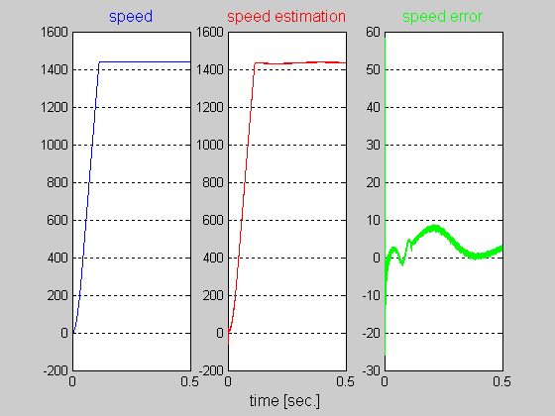
Fig.10. The rotor speed, estimated speed based on the MRAS algorithm and speed error for a robust controlled (using the optimal H∞ controller) starting process (rated speed step) with no load.

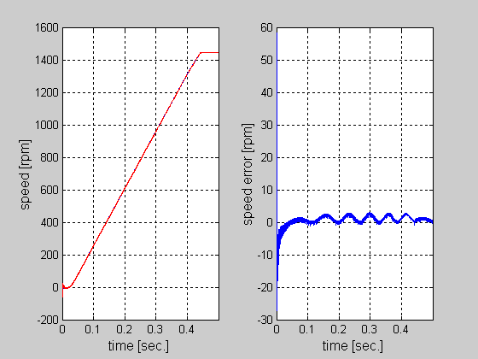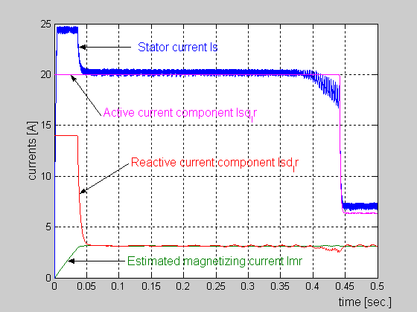
Fig.11. a) speed, estimated speed and speed error b) stator currents for a robust controlled starting process (rated speed step) with rated load.

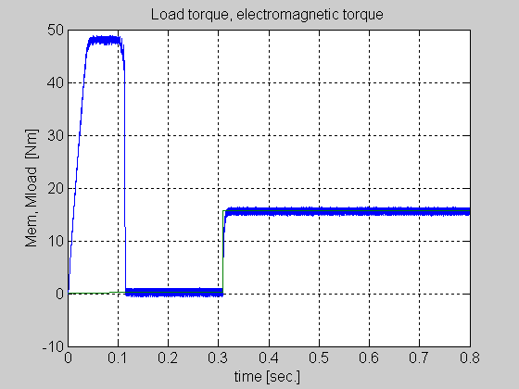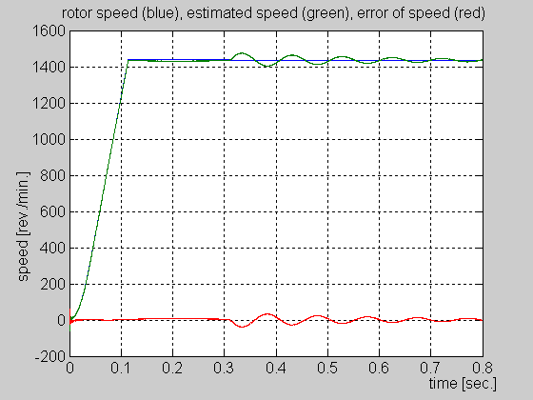
Fig.12. a) electromagnetic and load torque b) speed, estimated speed and speed error for a robust controlled load step.

