Induction Motors Stator Fault Detection and Diagnosis
by a Rather Simple Fuzzy Logic Approach.
A Case Study for Electric Machines Fuzzy Condition Monitoring

M.D. Mouss, L.H. Mouss, R. Abdessemed and M.E.H. Benbouzid

Abstract—Many researches dealt with the problem of induction motors fault detection and diagnosis. The major difficulty is the lack of an accurate model that describes a fault motor. Moreover, experienced engineers are often required to interpret measurement data that are frequently inconclusive. A fuzzy logic approach may help to diagnose induction motor faults. In fact, fuzzy logic is reminiscent of human thinking processes and natural language enabling decisions to be made based on vague information. Therefore, this paper applies fuzzy logic to induction motors fault detection and diagnosis. The motor condition is described using linguistic variables. Fuzzy subsets and the corresponding membership functions describe stator current amplitudes. A knowledge base, comprising rule and data bases, is built to support the fuzzy inference. The induction motor condition is diagnosed using a compositional rule of fuzzy inference.

Index Terms—Induction motor, diagnosis, fuzzy logic, stator current amplitudes.

I. Introduction

One of the most widely used techniques for obtaining information on the health state of induction motors is based on the processing of stator line current. Typically, in the motor fault diagnosis process, sensors are used to collect time domain current signals. The diagnostic expert then uses both time domain and frequency domain signals to study the motor condition and determines what faults are present [1-4]. However, experienced engineers are often required to interpret measurement data that are frequently inconclusive. A fuzzy logic approach may help to diagnose induction motor faults. In fact, fuzzy logic is reminiscent of human thinking processes and natural language enabling decisions to be made based on vague information.
Fuzzy logic allows items to be described as having a certain membership degree in a set. This allows a computer, which is normally constrained to 1 and 0, to delve into the continuous realm [5]. When conducting fault diagnosis, there are several situations in which an object is not obviously “good” or “bad”, but may fall into some interior range [6-8]. According to the fact that induction motor condition interpretation is a fuzzy concept [9], during the past few years, researchers have proposed some fuzzy logic based diagnosis approaches [10-22]. A major difficulty is the lack of a well processing of fuzzy input data.

M.D. Mouss, L.H. Mouss and R. Abdessemed are with the University of Batna, 1, Rue Chahid Boukhlouf Mohamed El Hadi, 05000 Batna, Algeria.
M.E.H. Benbouzid is with the University of Western Brittany, Rue de Kergoat, BP 93169, 29231 Brest Cedex 3, France.
This paper applies fuzzy logic, to the diagnosis of induction motor stator and phase conditions, based on the amplitude features of stator currents. This method has been chosen because fuzzy logic has proven ability in mimicking human decisions [23], and the stator voltage and phase condition monitoring problem has typically been solved [24-25]. The motor condition is described using linguistic variables. Fuzzy subsets and the corresponding membership functions describe stator current amplitudes. A knowledge base, comprising rule and databases, is built to support the fuzzy inference. The induction motor condition is diagnosed using a compositional rule of fuzzy inference. The generality of the proposed methodology has been experimentally tested on a 4-kW squirrel-cage induction motor. The obtained results indicate that the fuzzy logic approach, as proposed by the authors, is capable of highly accurate diagnosis.

II. Stator Current Monitoring System

A stator current signal contains potential fault information. The most suitable measurements for diagnosing the faults under consideration, in term of easy accessibility, reliability, and sensitivity, are the stator current amplitudes I_{a}, I_{b}, and I_{c}. These amplitudes are monitored by the system illustrated by Fig. 1.

Fig. 1. Block diagram of induction motor condition monitoring system.
III. Fuzzy Logic Based Diagnosis Approach

The main reason for choosing a fuzzy approach is the very nature of the changes in the attributes. It is nonlinear, and in addition, it would be unreasonable to expect that each time the same level of a particular fault arises, that the attributes would measure exactly the same values. The boundaries between two levels of a certain fault or between two faults are not sharply defined, and therefore the use of a classic true or false logic is inappropriate, whereas use of a fuzzy logic instead is highly justified. Membership functions and the degree of membership, rather than yes or no membership, give the opportunity, using previously acquired knowledge about the system attributes, to define and create a fuzzy rule based system that can be used as a diagnosis tool to monitor the condition of an induction motor.
Fuzzy systems rely on a set of rules. These rules, while superficially similar, allow the input to be fuzzy, i.e. more like the natural way that humans express knowledge. Thus, a power engineer might refer to an electrical machine as “somewhat secure” or a “little overloaded”. This linguistic input can be expressed directly by a fuzzy system. Therefore, the natural format greatly eases the interface between the engineer knowledge and the domain expert. Furthermore, infinite graduations of truth are allowed, a characteristic that accurately mirrors the real world, where decisions are seldom “crisp” [5].

A. Fuzzy System Input-Output Variables

As stated, the induction motor condition can be deduced by observing the stator current amplitudes. Interpretation of results is difficult as relationships between the motor condition and the current amplitudes are vague. Therefore, using fuzzy logic, numerical data are represented as linguistic information [26].
In our case, the stator current amplitudes I_{a}, I_{b}, and I_{c} are considered as the input variables to the fuzzy system. The stator condition, CM, is chosen as the output variable. All the system inputs and outputs are defined using fuzzy set theory.

$\begin{aligned}\left\{I_{a}=\left\{μ_{I_{a}}\left(i_{\text{aj}}\right)i_{\text{aj}}∈I_{a}\right\} | \right.\left\{I_{b}=\left\{μ_{I_{b}}\left(i_{\text{bj}}\right)i_{\text{bj}}∈I_{b}\right\} | \right.\end{aligned}$ (1)

$\text{CM}=\left\{μ_{\text{CM}}{\left({\text{cm}}_{j}\right)}/{{\text{cm}}_{j}}∈\text{CM}\right\}$ (2)

Where i_{aj}, i_{bj}, i_{cj}, and cm_{j} are, respectively, the elements of the discrete universe of discourse I_{a}, I_{b}, I_{c}, and CM. μ_{Ia}(i_{aj}), μ_{Ib}(i_{bj}), μ_{Ic}(i_{cj}), and μ_{CM}(cm_{j}), are, respectively, the corresponding membership functions.

B. Linguistic Variables

Basic tools of fuzzy logic are linguistic variables. Their values are words or sentences in a natural or artificial language, providing a means of systematic manipulation of vague and imprecise concepts. More specifically, a linguistic variable is characterized by a quintuple (x, T(x), U, G, M), where x is the variable name; T(x) is the set of names of the linguistic values of x, each a fuzzy variable, denoted generically by x and ranging over a universe of discourse U. G is a syntactic rule for generating the names of x values; M is the semantic rule associating a meaning with each value.
For instance, the term set T(CM), interpreting stator condition, CM, as a linguistic variable, could be

T(CM) = {Good, Damage, Seriously Damaged} (3)

Where each term in T(CM) is characterized by a fuzzy subset, in a universe of discourse CM. Good might be interpreted as a stator with no faults, damaged as a stator with voltage unbalance, and seriously damaged as a stator with an open phase. Figure 2 gives an illustration of the stator condition as a linguistic variable.
Similarly, the input variables I_{a}, I_{b}, and I_{c} are interpreted as linguistic variables, with

T(Q) = {Zero, Small, Medium, Big} (4)

Where Q = I_{a}, I_{b}, I_{c}, respectively.

C. Fuzzy and Membership Functions Construction

Fuzzy rules and membership functions are constructed by observing the data set. For the measurements related to the stator currents, more insight into the data is needed, so membership functions will be generated for zero, small, medium, and big. For the measurement related to the stator condition, it is only necessary to know if the stator condition is good, damaged, or seriously damaged. The optimized membership functions for this problem are shown in Figs. 3 and 4. Once the form of the initial membership functions has been determined, the fuzzy if-then rules can be derived. In this study, two faults have been investigated: stator voltage unbalance and open phase.
These rules have been optimized so as to cover all the healthy and the faulty cases. For our study, we have obtained the following 14 if-then rules.

Rule (1) : If I_{a} is Z Then CM is SD
Rule (2) : If I_{b} is Z Then CM is SD
Rule (3) : If I_{c} is Z Then CM is SD
Rule (4) : If I_{a} is B Then CM is SD
Rule (5) : If I_{b} is B Then CM is SD
Rule (6) : If I_{c} is B Then CM is SD
Rule (7) : If I_{a} is S and I_{b} is S and I_{c} is M Then CM is D
Rule (8) : If I_{a} is S and I_{b} is M and I_{c} is M Then CM is D
Rule (9) : If I_{a} is M and I_{b} is S and I_{c} is M Then CM is D
Rule (10) : If I_{a} is M and I_{b} is M and I_{c} is M Then CM is G
Rule (11) : If I_{a} is S and I_{b} is S and I_{c} is S Then CM is G
Rule (12) : If I_{a} is S and I_{b} is M and I_{c} is S Then CM is D
Rule (13) : If I_{a} is M and I_{b} is S and I_{c} is S Then CM is D
Rule (14) : If I_{a} is M and I_{b} is M and I_{c} is S Then CM is D

Fig. 2. Linguistic variables of the induction motor stator condition.

Fig. 3. Fuzzy membership functions for stator currents.
(Z: Zero, S: Small, M: Medium, and B: Big)

Fig. 4. Fuzzy membership functions for the stator condition.
(G: Good, D: Damaged, and SD: Seriously Damaged)

The extraction process consists in the following steps [6]:
– Fuzzification: Conversion of crisp facts (inputs) into fuzzy sets described by linguistic expressions.
– Inference: Fuzzy if-then rules express fuzzy implication relation between the premise fuzzy sets and the conclusion fuzzy sets of the. In our case, a Mamdani-type fuzzy inference system is used.
– Defuzzification: Various defuzzification methods can be applied. In our case, the system uses Max-Min composition and the centroid of area method for defuzzification.
The extracted rules are observed to be in agreement with the working principle of the system.

IV. Experiments

Figure 5 sketches the experimental set up. It consists in a 4-kW, 220/380 V, 15/8.6 A, 50-Hz, 4 pole, Δ-connected squirrel-cage induction motor coupled to a DC machine feeding a variable resistor. The stator currents are sampled with a 1 kHz sampling rate and interfaced to a computer by a data acquisition board.
The induction motor has been initially tested, in absence of faults, in order to determine the stator currents corresponding to the supposed healthy motor (Fig. 6). Afterward, two kinds of experiments have been carried out. In the first one, stator voltages were unbalanced by adding a 0.2 p.u. resistance to one phase. The second one has concerned a single-phase effect corresponding to stator open phase. The stator currents corresponding to these faulty conditions are respectively shown by Figs. 7 and 8.

Fig. 5. Schematic view of the experimental set up.
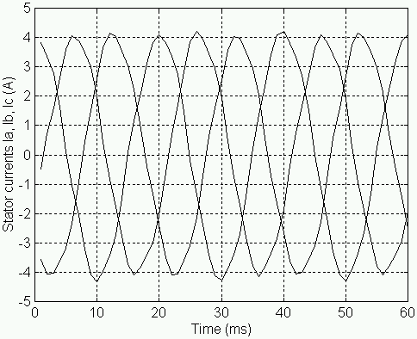

(a) Unloaded motor.

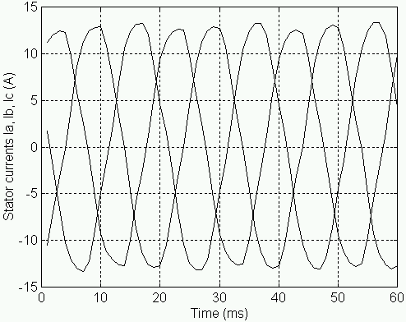

(b) Fully loaded motor.

Fig. 6. Induction motor healthy condition.

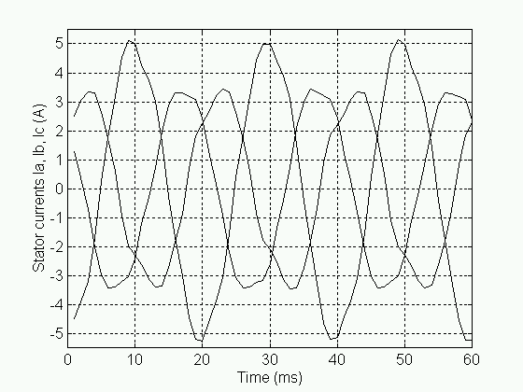

(a) Unloaded motor.
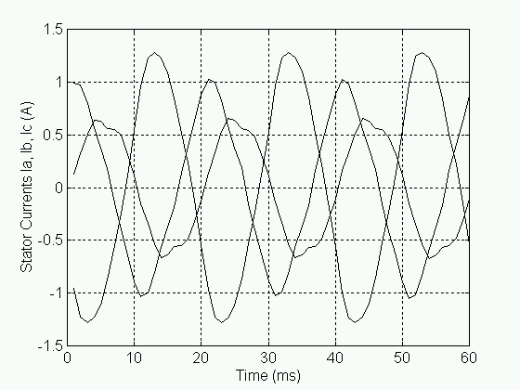

(b) Fully loaded motor.

Fig. 7. Stator currents for voltage unbalance.
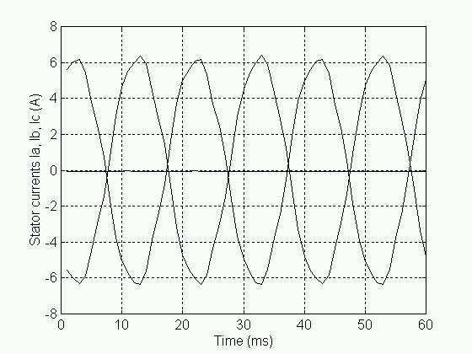

(a) Unloaded motor.

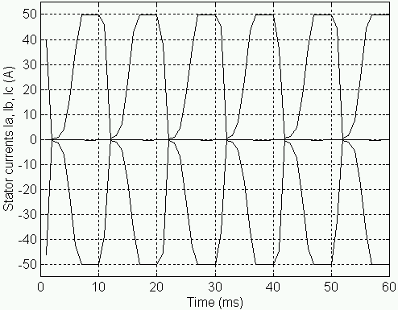

(b) Fully loaded motor.

Fig. 8. Stator currents for open phase.

V. Fuzzy Fault Detection and Diagnosis

Using the system depicted by Fig. 1, stator currents were measured (Figs. 6, 7 and 8) and their amplitudes derived. These amplitudes were transferred into the corresponding discourse universe as inputs. The fuzzy logic inference engine evaluates the inputs using the knowledge base and then diagnoses the stator condition.
For illustration, Figs. 9, 10, and 11 show fuzzy inference diagrams for different stator currents for which the induction motor stator condition is good, damaged, or seriously damaged. As it could be noticed, fuzzy rules are solicited, according to stator current amplitudes, leading to the determination of the motor condition.
For Fig. 10, it is rule (11) that is solicited, in fact I_{a} = I_{b} = 5I_{c} = 5 A are small “S”. The motor is in this case supposed healthy (CM = 0.05). For Fig. 11, it is rule (12) that is solicited, in fact I_{a} = I_{c} = 5 A are small “S”, and I_{b} = 15 A is medium “M”. The motor is in this case damaged (CM = 0.5). Finally, for Fig. 12, it is rule (1) that is solicited (I_{a} = 0), or rule (6), in I_{c} = 35 A is big “B”. The motor is in this case seriously damaged (CM = 0.975).
The performances of the proposed fuzzy logic approach, as shown in Table 1, are quite good. In fact, they indicate that it is capable of highly accurate diagnosis.

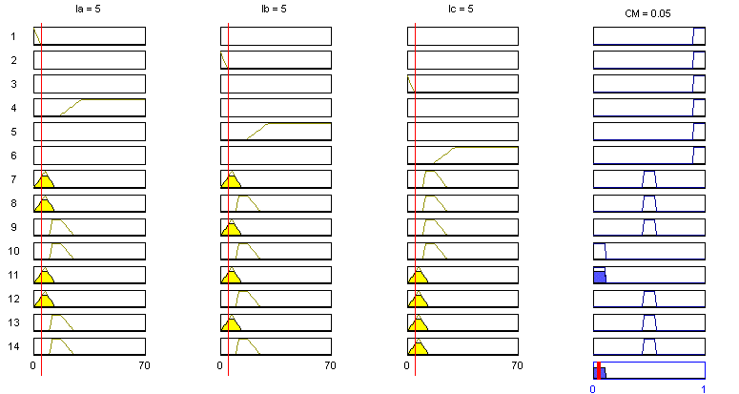

Fig. 9. Fuzzy inference diagram for a healthy motor.

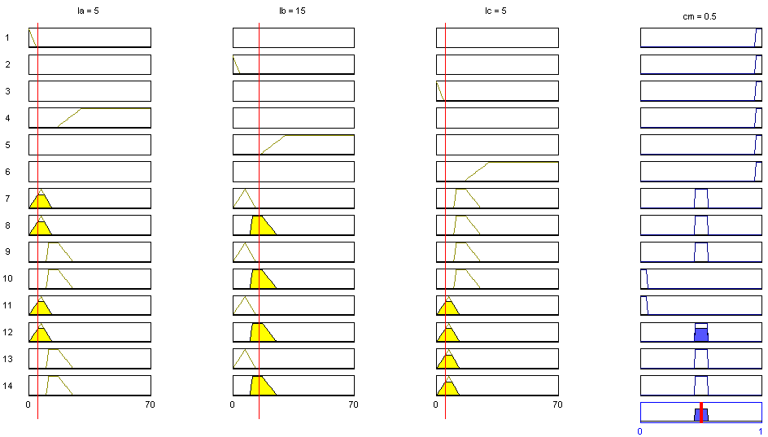

Fig. 9. Fuzzy inference diagram for a damaged motor.

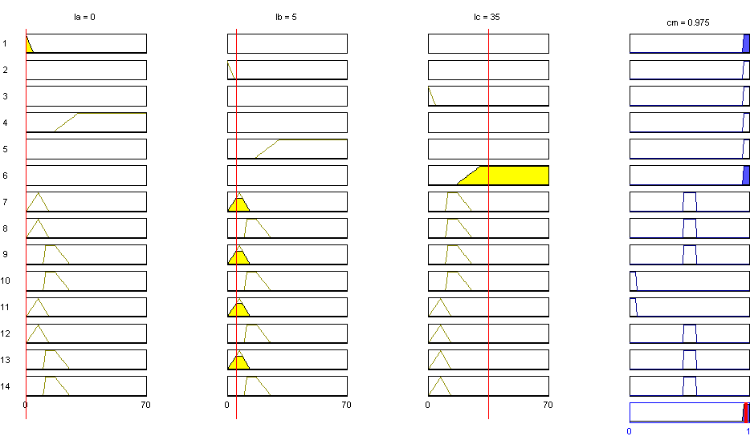

Fig. 10. Fuzzy inference diagram for a seriously damaged motor.

Table 1. Fuzzy logic fault diagnosis performance.

Fault Detection Diagnosis Accuracy

Good Conditions (Healthy Motor) 100%
Bad Conditions (Voltage Unbalance) 100%
Severe Conditions (Open Phase) 94%

VI. Conclusion

A rather simple fuzzy logic method to interpret current sensors signal for induction motor fault detection and diagnosis was presented. Correctly processing theses current signals and inputting them to a fuzzy decision system achieved high diagnosis accuracy.
Experimental results have been presented in terms of motor fault detection accuracy and knowledge extraction feasibility. These results clearly indicate that the proposed fuzzy approach is both accurate and easy-to-implement. The presented work could be considered as a case study to introduce post-graduate students to electric machines fuzzy condition monitoring.

Appendix
Rated Parameters of the Induction Motor Under Test

Rated values Power 4 kW
Frequency 50 Hz
Voltage (Δ/Y) 220/380 V
Current (Δ/Y) 15/8.6 A
Speed 1440 rpm
Pole pair (p) 2

References

- G.B. Kliman et al., “Methods of motor current signature analysis,” Electric Machines & Power Systems, vol. 20, n°5, September 1992, pp. 463-474.
- M.E.H. Benbouzid and G.B. Kliman., “What stator current processing based technique to use for induction motor rotor faults diagnosis?,” IEEE Trans. Energy Conversion, vol. 18, n°2, pp. 238-244, June 2003.
- M.E.H. Benbouzid, “A review of induction motors signature analysis as a medium for faults detection,” IEEE Trans. Industrial Electronics, vol. 47, n°5, October 2000, pp. 984-993.
- M.E.H. Benbouzid, “Bibliography on induction motors faults detection and diagnosis,” IEEE Trans. Energy Conversion, vol. 14, n°4, December 1999, pp. 1065-1074.
- J.M. Mendel, “Fuzzy logic systems for engineering: a tutorial,” Proceedings of the IEEE, vol. 83, n°3, March 1995, pp. 345-377.
- M.Y. Chow et al., Motor Incipient Fault Detection Using Artificial Neural Network and Fuzzy Logic Technologies, in Computer Aided Maintenance, Methodology and Practices. J. Lee, Ed.: Chapman Hall, 1996.
- M.Y. Chow, Methodologies of Using Neural Network and Fuzzy Logic Technologies for Motor Incipient Fault Detection. Singapore: World Scientific Publishing Co. Pte. Ltd., 1997.
- M.Y. Chow et al., Intelligent Motor Fault Detection, in Intelligent Techniques in Industry. L.C. Jain, Ed.: CRC Press, 1998.
- H.J. Zimmermann, Fuzzy Set Theory and Its Applications. Kluwer Academic Publishers, 1991.
- P.V. Goode et al., “Neural/fuzzy systems for incipient fault detection in induction motors,” Proceedings of the 1993 International Conference of the IEEE Industrial Electronics Society, Maui (USA).
- E. Ritchie et al., “Diagnosis of rotor faults in squirrel cage induction motors using a fuzzy logic approach,” Proceedings of the 1994 International Conference on Electrical Machines, Paris (France), vol. 2, pp. 348-352.
- P.V. Goode et al., “A hybrid fuzzy/neural system used to extract heuristic knowledge from a fault detection problem,” Proceedings of the 1994 IEEE World Congress on Computational intelligence, Orlando (USA), vol. 3, pp. 1731-1736.
- P.V. Goode et al., “Using a neural/fuzzy system to extract knowledge of incipient fault in induction motors Part I - Methodology,” IEEE Trans. Industrial Electronics, vol. 42, n°2, April 1995, pp., 131-138.
- P.V. Goode et al., “Using a neural/fuzzy system to extract knowledge of incipient fault in induction motors Part II - Application,” IEEE Trans. Industrial Electronics, vol. 42, n°2, April 1995, pp. 139-146.
- F. Filippetti et al., “A fuzzy logic approach to on-line induction motor diagnostics based on stator current monitoring,” Proceedings of the 1995 IEEE International PowerTech Conference, Stockholm (Sweden), vol. EMD, pp. 156-161.
- N.M. Roehl et al., “Fuzzy ART neural network approach for incipient fault detection and isolation in rotating machines,” Proceedings of the 1995 IEEE International Conference on Neural Networks, vol. 1, pp. 538-542.
- S. Altug et al., “Comparative analysis of fuzzy inference systems implemented on neural structures,” Proceedings of the 1997 International Conference on Neural Networks, Houston (USA), vol. 1, pp. 426-431.
- S. Chun et al., “A fuzzy expert system for vibration cause identification in rotating machines,” Proceedings of the 1997 IEEE International Conference on Fuzzy Systems, vol. 1, pp. 555-560.
- J. Boyce et al., “Pump motor vibration analysis and fault detection using artificial neural/fuzzy system,” Proceedings of the 1997 International Conference on Maintenance and Reliability, Knoxville (USA), vol. 2, pp. 60.01-60.15.
- S. Caldara et al., “A fuzzy diagnostic System: application to linear induction motor drives,” Proceedings of the 1997 IEEE Instrumentation and Measurement Technology Conference, Ottawa (Canada), vol. 1, pp. 257-262.
- M.Y. Chow et al., “Set theoretic based neural-fuzzy motor fault detector,” Proceedings of the 1998 International Conference of the IEEE Industrial Electronics Society, Aachen (Germany), vol. 4, pp. 1908-1913.
- G. Goddu et al., “Motor bearing fault diagnosis by a fundamental frequency amplitude based fuzzy decision system,” Proceedings of the 1998 International Conference of the IEEE Industrial Electronics Society, Aachen (Germany), vol. 4, pp. 1961-1965.
- T. Ross, Fuzzy Logic with Engineering Applications. New York: McGraw-Hill, 1995.
- M.E.H. Benbouzid et al., “Induction motor faults detection using advanced spectral analysis technique,” Proceedings of the 1998 International Conference on Electrical Machines, Istanbul (Turkey), vol. 3, pp. 1849-1854.
- M.E.H. Benbouzid et al., “Induction motors faults detection and localization using stator current advanced signal processing techniques,” IEEE Trans. Power Electronics, vol. 14, n°1, January 1999, pp. 14-22.
- H.L. Poon, “Verbal time series reports generation in condition monitoring,” Computers in Industry, vol. 15, 1990, pp. 293-301.

Mohamed Djamel MOUSS was born in Batna, Algeria, in 1956. He received the B.Sc. degree in Electrical Engineering, in 1982, from the National Polytechnic School of Algiers, Algeria; the M.Sc. degree in Industrial Electricity, in 1989, from the University of Batna (Algeria); and presently is in the process of completing a Ph.D. degree in Industrial Engineering at the University of Batna, (Algeria).
After graduation, he joined the University of Batna, Algeria, where he is an Assistant Professor of Electrical and Computer Engineering. M. Mouss current research interests include industrial diagnosis of production system using artificial intelligence techniques.

Leila Hayet MOUSS was born in Batna, Algeria, in 1954. She received the B.Sc. degree in Electrical Engineering, in 1979, from the National Polytechnic School of Algiers, Algeria; the M.Sc. and Ph.D. degrees both in Electrical and Computer Engineering, from the University Bordeaux, France, in 1982 and 1987 respectively.
After graduation, she joined the University of Batna, Algeria, where she is a Professor of Electrical and Computer Engineering. Dr. Mouss is a member of New York Academy of Science. She is the head of the Automatic and Computer Integrated Manufacturing Laboratory of the University of Batna. Dr. Mouss current research interests include industrial diagnosis of production system.


Rachid Abdessemed was born in Batna, Algeria, in 1951. He received the M.Sc. and Ph.D. degrees in Electrical Engineering, from Kiev Polytechnic Institute, Ukraine, in 1982.
He has been working for more than eighteen years at the University of Batna where he is a Professor in the Electrical Engineering Department. Currently, he is the head of the Electrical Engineering Laboratory. His current area of research includes design and control of induction machines, reliability, magnetic bearings, and renewable energy.


Mohamed El Hachemi BENBOUZID was born in Batna, Algeria, in 1968. He received the B.Sc. degree in Electrical Engineering, in 1990, from the University of Batna, Algeria; the M.Sc. and Ph.D. degrees both in Electrical and Computer Engineering, from the National Polytechnic Institute of Grenoble, France, in 1991 and 1994 respectively.
After graduation, he joined the University of Picardie “Jules Verne”, France, where he was an Associate Professor of Electrical and Computer Engineering at the Professional Institute of Amiens. In November 2000, he received the “Habilitation à Diriger des Recherches” degree from the University of Picardie “Jules Verne”. In September 2004, he joins the IUT of Brest, University of Western Brittany as Professor of Electrical Engineering. His main research interests and experience include analysis, design, and control of electric machines, variable speed drives for traction and propulsion applications, and fault diagnosis of electric machines. Dr. Benbouzid is a Senior Member of the IEEE.

